**THE MARINA BEACH**

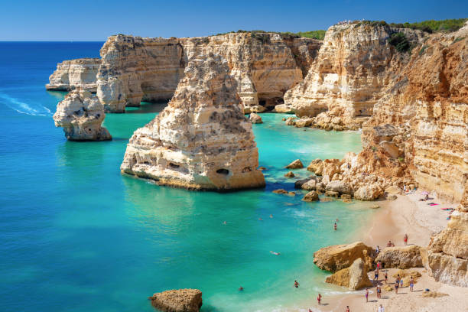**Marina Beach**, or simply the **Marina**, is a natural [urban beach](https://en.wikipedia.org/wiki/Urban_beach) in [Chennai](https://en.wikipedia.org/wiki/Chennai), [Tamil Nadu](https://en.wikipedia.org/wiki/Tamil_Nadu), [India](https://en.wikipedia.org/wiki/India), along the [Bay of Bengal](https://en.wikipedia.org/wiki/Bay_of_Bengal). The beach runs from near [Fort St. George](https://en.wikipedia.org/wiki/Fort_St._George) in the north to [Foreshore Estate](https://en.wikipedia.org/wiki/Foreshore_Estate) in the south, a distance of 6.0 km (3.7 mi), making it the second longest urban beach in the world, after [Cox's Bazar Beach](https://en.wikipedia.org/wiki/Cox%27s_Bazar_Beach). It is a prominent landmark in Chennai.